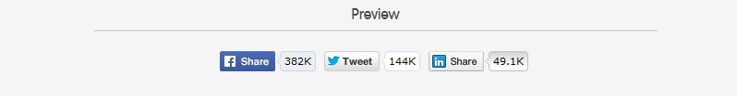
Code for Social Networks - Sharing buttons

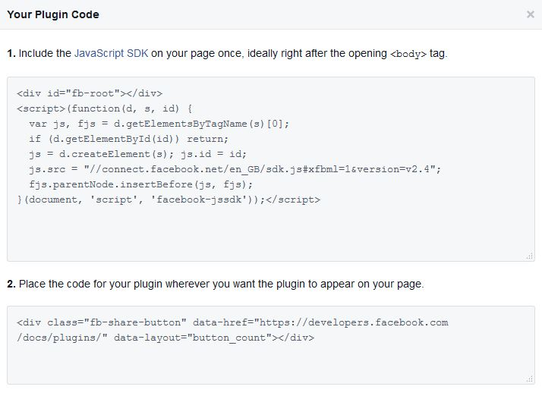
- Share on Facebook
You have to include JavaScript SDK
- Include the JavaScript SDK on your page once, ideally right after the opening <body> tag.
<div id="fb-root"></div>
<script>(function(d, s, id) {
var js, fjs = d.getElementsByTagName(s)[0];
if (d.getElementById(id)) return;
js = d.createElement(s); js.id = id;
js.src = "//connect.facebook.net/en_GB/sdk.js#xfbml=1&version=v2.4";
fjs.parentNode.insertBefore(js, fjs);
}(document, 'script', 'facebook-jssdk'));</script>

- Place the code for your plugin wherever you want the plugin to appear on your page
<div class="fb-share-button" data-href="https://developers.facebook.com/docs/plugins/" data-layout="button_count"></div>
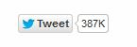
- Share on Twitter
https://dev.twitter.com/web/tweet-button
How to add a Tweet button to your website?
- Create a new anchor element with a twitter-share-button class to allow Twitter’s widgets JavaScript to discover the element and enhance the link into a Tweet button. Set a href attribute value of https://twitter.com/intent/tweet to create a link to the Twitter web intent composer.
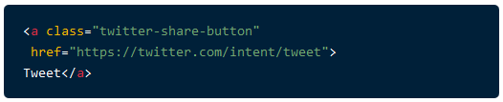
<a class="twitter-share-button"
href="https://twitter.com/intent/tweet">
Tweet</a>

- Pre-populate Tweet text and suggest related accounts by customizing Tweet web intent query parameters.
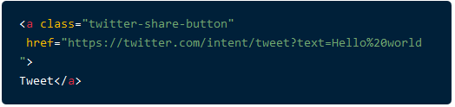
<a class="twitter-share-button"
href="https://twitter.com/intent/tweet?text=Hello%20world">
Tweet</a>

- Customize Tweet button parameters using data-* attributes.
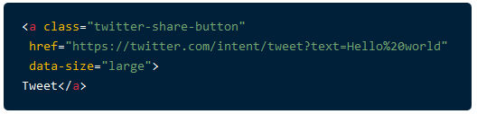
<a class="twitter-share-button"
href="https://twitter.com/intent/tweet?text=Hello%20world"
data-size="large">
Tweet</a>

- Asynchronously load Twitter’s widgets JavaScript using our loading snippet. The JavaScript snippet will check for an existing version of Twitter’s widgets JavaScript on the current page, initialize a function queue to be executed once the widgets JavaScript has loaded, and load the widgets JavaScript asynchronously from Twitter’s CDN.

Tweet text components
text
A text parameter appears pre-selected in a Tweet composer. The Tweet author may easily remove the text with a single delete action.
The text parameter may be auto-populated from the webpage’s <title> element if not explicitly set.
url
The url parameter contains an absolute HTTP or HTTPS URL to be shared on Twitter. The shared URL will be shortened by Twitter’s t.co service in a published Tweet. A Twitter Card may be appear for a shared URL.
The url parameter may be auto-populated from a canonical link element (<link rel="canonical">) or the location.href of the page when not explicitly set.
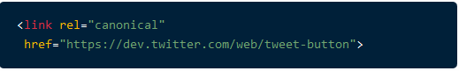
<link rel="canonical"
href="https://dev.twitter.com/web/tweet-button">

Set a data-counturl attribute when your shared URL differs from the canonical representation of your page.

hashtags
Add a comma-separated list of hashtags to a Tweet using the hashtags parameter. Omit a preceding “#” from each hashtag; the Tweet composer will automatically add the proper space-separated hashtag by language.

via
Attribute the source of a Tweet to a Twitter username using the via parameter. The attribution will appear in a Tweet as ” via @username” translated into the language of the Tweet author.
A via parameter may be auto-populated from a link or anchor element linked to a Twitter profile page with a me relationship token.
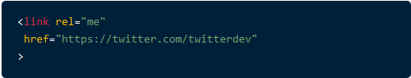
<link rel="me"
href="https://twitter.com/twitterdev"
>

Button customization
Tweet count
The Tweet button displays a count of the number of times a URL has been shared in Tweets. You may wish to set a separate count URL from the URL to be shared using the counturl data attribute.
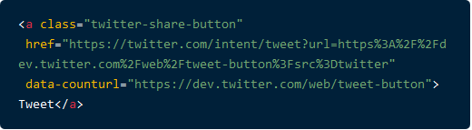
<a class="twitter-share-button"
href="https://twitter.com/intent/tweet?url=https%3A%2F%2Fdev.twitter.com%2Fweb%2Ftweet-button%3Fsrc%3Dtwitter"
data-counturl="https://dev.twitter.com/web/tweet-button">
Tweet</a>

The Tweet count displays to the right of the Tweet button by default (left in right-to-left languages). Set a count value of none to hide the Tweet count or vertical to display a count above the button.
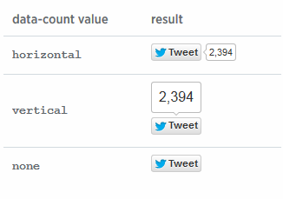
Note: If your count does not seem to increase correctly, make sure your server supports HTTP HEAD requests, as described in this Tweet button FAQ entry:
To improve performance Twitter caches the count before displaying it. The cache is updated frequently but on some occasions it may look like the count is not increasing while the cache is updated. In addition, the count only includes public Tweets (meaning a Tweet from a protected account will not cause an increase).
There is currently a requirement that your server support HTTP HEAD requests in order to update the count properly. An easy way to check this is to use the command-line curl program, passing the -I (capital i) flag.
A successful request should have a HTTP 200 OK response:
$ curl -I https://dev.twitter.com
HTTP/1.1 200 OK
Date: Thu, 22 Sep 2011 23:16:39 GMT
Server: Apache
Cache-Control: no-cache, no-store, must-revalidate, post-check=0, pre-check=0
Expires: Sun, 11 Mar 1984 12:00:00 GMT
Pragma: no-cache
Last-Modified: Thu, 22 Sep 2011 23:16:20 +0000
Vary: Cookie,Accept-Encoding
Connection: close
Content-Type: text/html; charset=utf-8
...

An unsuccessful request may return a HTTP 4xx or 5xx error:
$ curl -I http://baddomain.example.com
HTTP/1.1 405 Method Not Allowed
...

The Tweet Button works over HTTPS.

- Share on LinkedIn

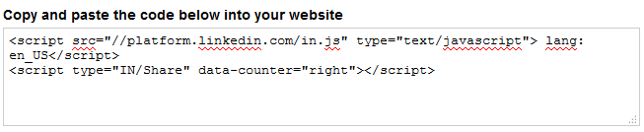
<script src="//platform.linkedin.com/in.js" type="text/javascript"> lang: en_US</script>
<script type="IN/Share" data-counter="right"></script>

